National University of Computer and Emerging Sciences



Lab Exercise 07

CL461-Artificial Intelligence Lab

|  |  |
| --- | --- |
| Course Instructor | Dr. Kashif Zafar |
| Lab Instructor (s) | Muhammad Saddam  Ahmad Abdullah |
| Section | BCS-6D |
| Semester | Spring 2021 |

Department of Computer Science

FAST-NU, Lahore, Pakistan

# Exercises

## Exercise 1:

A thief enters a shop carrying bag which can carry 35 kgs of weight. The shop has 10 items, each with a specific weight and price. Now, the thief’s dilemma is to make such a selection of items that it maximizes the value (i.e., total price) without exceeding the knapsack weight. We have to help the thief to make the selection.

Available Items are:

**Item No. Weight Value**

1 3 266

2 13 442

3 10 671

4 9 526

5 7 388

6 1 245

7 8 210

8 8 145

9 2 126

10 9 322

**Initial population:**

[[0 1 0 1 1 0 0 1 1 1]

[1 1 1 1 0 1 1 1 0 0]

[0 1 0 0 0 0 1 1 0 1]

[0 0 1 0 1 1 0 0 0 0]

[0 0 1 1 0 0 0 0 0 1]

[0 1 0 1 1 0 1 0 0 0]

[1 1 1 0 0 0 1 0 1 0]

[0 0 0 0 1 1 1 0 0 0]]

**Fitness Function:**

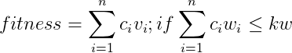



where,

n = chromosome length

Ci = ith gene

Vi = ith value

Wi = ith weight

kw = allowed weight

To generate new population:

1. One point crossover

Example of one point cross-over.

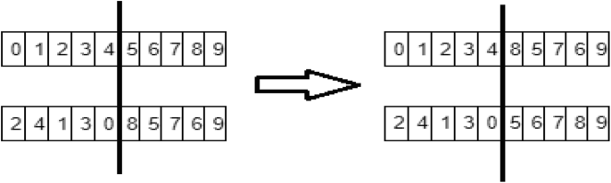

1. Mutate offspring got from cross over at 3 random positions. Select 3 random positions: if you find 1change it to 0 and vice versa.

Always keep 8 best chromosomes. If your program taking time you can iterate for fixed number of iterations.

# Submission Instructions

Always read the submission instructions carefully.

* Rename your Jupyter notebook to your roll number and download the notebook as **.ipynb** extension.
* To download the required file, go to **File->Download .ipynb**
* Only submit the **.ipynb** file. DO NOT **zip** or **rar** your submission file.
* Submit this file on Google Classroom under the relevant assignment.
* Late submissions will not be accepted.